**NAME:**

**Muhammad Huzaifa Khan**

**FATHER NAME:**

**Muhammad Nawab Khan**

**CLASS:**

**BSSE**

**SEMASTER:**

**1st Semaster**

**SEAT NO:**

**508587**

**ROLL NO:**

**49**

**COURSE NAME:**

**Introduction to Computer Science with Contemporary Language (Code # 305)**

**Assignment 1(a)**

**Introduction to Algorithm and Programming Logic**

**Q.**   **Write a program that takes input radius of a circle and prints Area of Circle (Area of circle=πr2 ) and Area of sphere of same radius (area of sphere = 4/3 πr³)**

**Ans.** PROGRAM CODE:

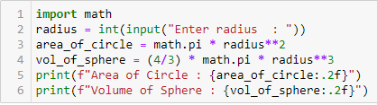

SOURCE CODE:  
import math

radius = int(input("Enter radius : "))

area_of_circle = math.pi * radius**2

vol_of_sphere = (4/3) * math.pi * radius**3

print(f"Area of Circle : {area_of_circle:.2f}")

print(f"Volume of Sphere : {vol_of_sphere:.2f}")

RESULT:



**Q. Write pseudo-code to a convert a centigrade temperature to Fahrenheit. Formula for this conversion is F = C * 9 / 5 + 32. Where C is temperature in centigrade and F = temperature in Fahrenheit.**

**Ans.** PSEUDO CODE:

GET temp_in_cent

COMPUTE temp_in_faren = temp_in_cent * 9 / 5 + 32

PRINT temp_in_faren

**Q. Write pseudo-code to a convert a Fahrenheit temperature to centigrade. (Transform the formula for finding the Fahrenheit temperature given above)**

**Ans.** PSEUDO CODE:

Get temp_in_faren

COMPUTE temp_in_cent = (temp_in_faren-32) * (5/9)

PRINT temp_in_cent

**Q. Write pseudo code to input current selling price and discount percentage and print discounted selling price.**

**Ans.** PSEUDO CODE:

GET price

GET discount

COMPUTE dics_price = price * discount/100

PRINT disc_price

**Q. Write a program that takes input width and depth of a hockey ground in meters, and price of Astroturf in Rs. Per square foot. The required output is the area of the ground in square feet and cost of Astroturf for the ground.**

**Ans.** PROGRAM CODE:

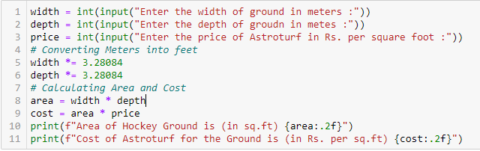

SOURCE CODE:

width = int(input("Enter the width of ground in meters :"))

depth = int(input("Enter the depth of groudn in metes :"))

price = int(input("Enter the price of Astroturf in Rs. per square foot :"))

# Converting Meters into feet

width *= 3.28084

depth *= 3.28084

# Calculating Area and Cost

area = width * depth

cost = area * price

print(f"Area of Hockey Ground is (in sq.ft) {area:.2f}")

print(f"Cost of Astroturf for the Ground is (in Rs. per sq.ft) {cost:.2f}")

RESULT:

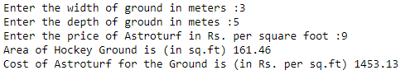

**Assignment 1(b)**

**Introduction to Python Programming**

**Q. Write a python programs to solve physics problems. Use your innovation to formulate a question first and then write its python program**

PROGRAM CODE:

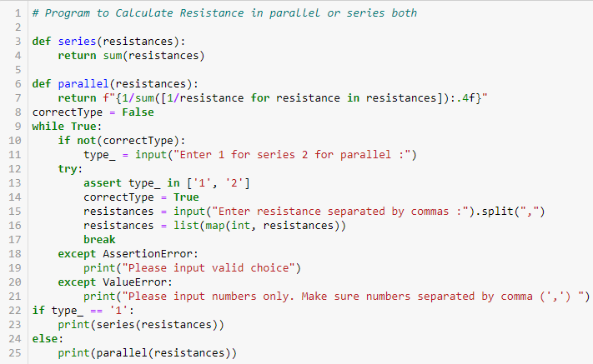

RESULT:

